# List APIs

## Google maps API(Mapping API) :

Google Maps is the biggest player in the web mapping space . It offers :

* large library of related APIs (such as drawing library which allows us to draw markers or polygons)

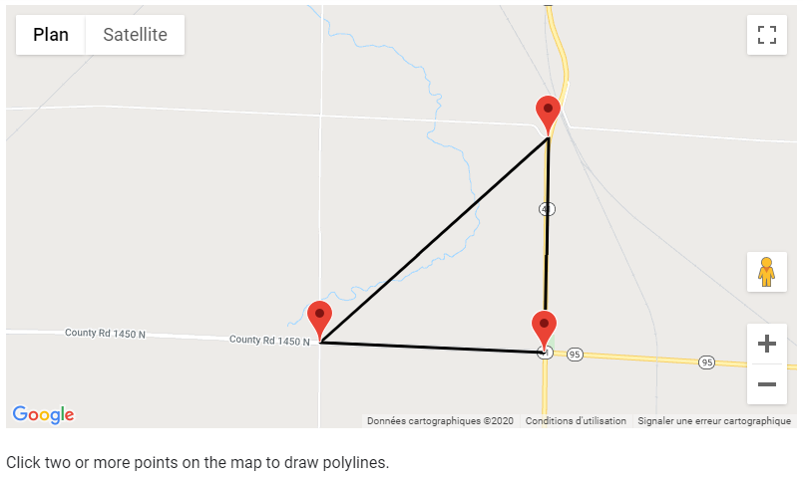

* extensive documentation

and many services like:

* Google Maps Distance Matrix API: Calculates distances based on start and destination points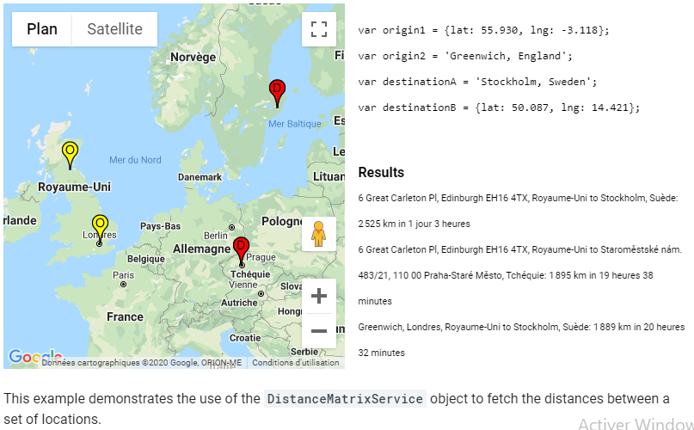
* 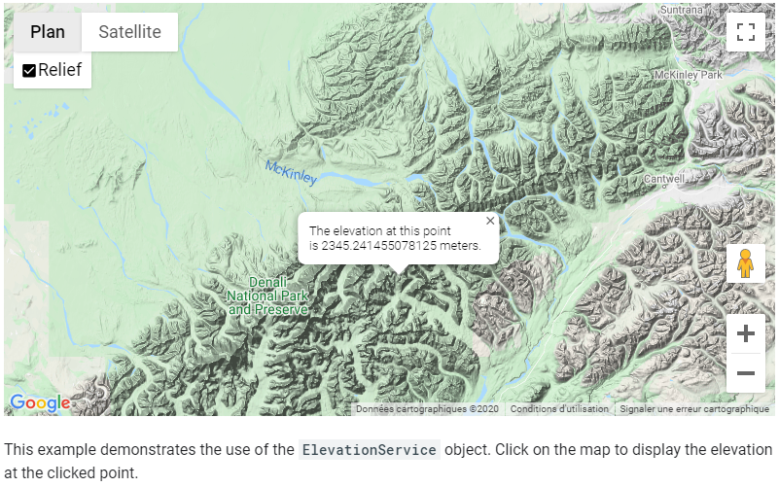Google Maps Eleveation API: provides elevation data for all locations on the surface of the earth, including depth locations on the ocean floor
* The combinaition between these two services will be useful to measure the degree of a slope :

Degree = tan-1(∆Elevation/Distance)

## Solcast API (Meteorological API)

The Solcast API delivers solar radiation and PV power data for anywhere on Earth: historical, live and forecast.

It offers :

* Utility Scale(not free) : Satellite imagery, PV plant measurements and sky-imagers are what power the Solcast Utility Scale Solar Forecast product.
* Grid Aggregations : pair up the rapid update, global cloud nowcasting system with your PV installation data to provide live, forecast and historical estimates of total distributed solar power output.
* Solar Irradiance Data (free for researchers) : offers forecast and real-time solar irradiance and weather data with global coverage and built-in accuracy reporting

It offers forecast data such as :

* Global Horizontal Irradiance (W/m2)
* Direct Normal Irradiance (W/m2)
* Diffuse Horizontal Irradiance (W/m2)
* Air temperature (degrees Celsius)
* Solar zenith angle(degrees)
* Solar azimuth angle
* The attenuation of incoming light due to cloud.
* Rooftop Sites (free for researchers) : Rooftop sites are PV sites that have a fixed tilt and capacity under 1MW. This API is suited to small to medium PV sites, usually on a rooftop of a residential home or a commercial building.